THE HISTORY OF MARTHAM
MARTHAM IN PRE-HISTORIC TIMES
Archaeology has revealed that the first settlers are known to have been here in the period that became known as the Mesolithic period or Middle Stone Age - roughly 8,000 BC to 2700 BC.
An indication of a Middle Stone Age settlement, has been found at Moregrove, on the northern edge of the village, where animal bones and flint implements have been discovered, both dating from that period. The spring-fed pond there would have provided an ideal water source for the early settlers to live alongside.
At Moregrove there is evidence too of habitation during the New Stone Age – the Neolithic Age – of roughly 2700 – 1700 BC, by which time people were becoming more permanently settled farmers of a few selected animals as distinct from hunters of all sorts of prey.
We know that people lived here in the Bronze Age (roughly 1900 – 750 BC), which gradually followed the Neolithic Age. This was the age when metal work developed and people began making articles from what we call bronze. It also became customary for people to be cremated after death and the remains being buried within a circle that would mark their burial place. Bronze Age burial circles have been located in the field south of the Somerton Road, almost opposite the present High School. These could be identified until late twentieth century deep ploughing destroyed them, now they are visible only through recent aerial photographs.
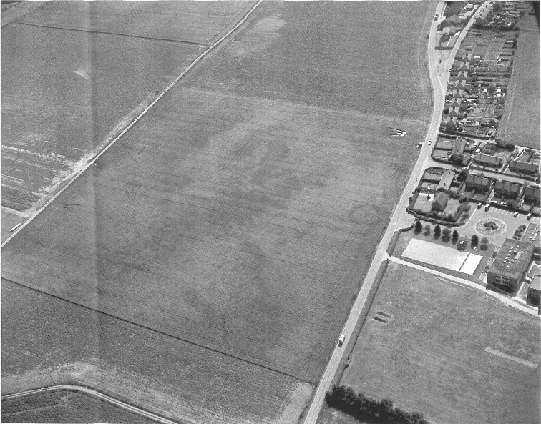
©Gressenhall Museum – Bronze Age Burial Crop Mark, Somerton Road, Martham

ROMAN TIMES
By the time the Romans occupied England in 43 AD. the island of Flegg was probably very sparsely populated. There is no known evidence of a Roman settlement in Martham, however Roman coins and other artefacts have been found within the parish, indicating that there was activity here.
Some time before the Romans withdrew from England, east Norfolk was being attacked by Saxons from across the sea, hence the building of the Roman Fort at Caister on Sea, and the huge defences at Burgh Castle. These were important Roman fortifications but were abandoned by 410 AD.
ANGLO SAXON TIMES
After the Romans withdrew from their occupation of east Norfolk, it provided the opportunity for others to settle. Anglo-Saxons, seeking new territories, arrived during the fifth and sixth centuries. There is no evidence of opposition to their settlement.
A group of the new settlers may have sailed up the River Bure and then the Muck Fleet which in ancient times was much wider. They may have landed at Fleggburgh and then walked northwards, assessing the fertility of the soil. Finding several spring fed ponds here at Martham, they realised that it was an ideal place to settle. To the settlers, the fertility of the sandy loam soil was of paramount importance. There were patches of less well-drained land. This was where people pastured their livestock as it was ideal for grazing. This land eventually became the Martham Village Green familiar to us today. It was far more extensive in Saxon times, even reaching to the present Staithe Road.

Pine Marten (Caroline Legg)
Place names tell us a great deal about settlements. Martham means the 'ham' or place where pine martens are to be found. Pine martens flourished on the wooded marshland by the River Thurne until their habitat was destroyed when the marshes were drained early in the 19th century.
Martham settlers may have used land at Somerton for summer pasture, and gone to Winterton for fishing in the winter. Place names with the 'ton' endings are sometimes off-shoots of another settlement.
Martham had sufficient fertile land to support a substantial community.
The Saxon settlers were pagan. A piece of pottery which was part of a pagan Saxon burial urn and a pagan Saxon brooch have been found by people field walking.
Pagan people always gathered somewhere to worship their gods. At Martham it was probably the highest point of the grazing area. A large stone, which sits at the entrance to the footpath opposite the car park of the Parish Church, has been identified as a Sarsen Stone, which was the pagan altar stone. It comes from the same place as some of the stones of Stonehenge. When they became Christians, that stone would have become the altar around which they gathered for Christian worship and eventually used in the first church.
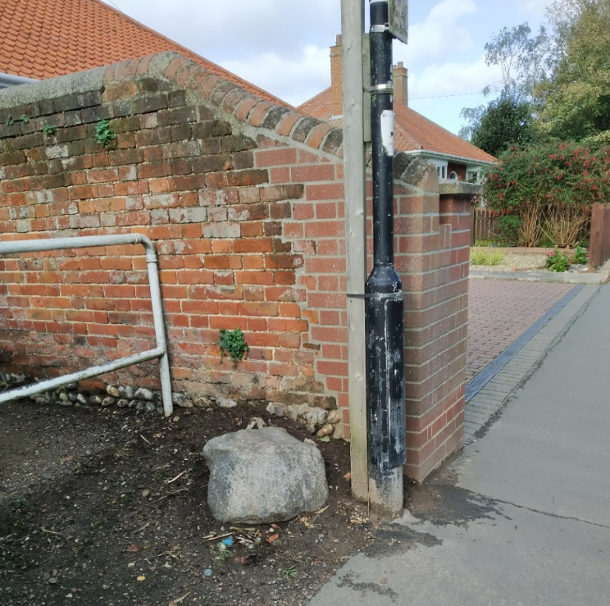
Sarsen Stone, Martham
So, when did the Martham people become Christians?
St. Fursey came to East Anglia about 630 AD and built a monastery inside Burgh Castle as the centre for his mission. From there he and his followers would have gone on their preaching tours. Martham being within easy reach, the missionaries are likely to have preached where people were already gathering to worship their Pagan gods. Naturally, that became the place for Christian worship. Martham possibly became a Christian community by the end of the seventh century.
THE DANISH INVASION OF FLEGG
The period 865 – 878 AD was that of the major Viking invasions of England, when people from Scandinavia invaded and then settled in much of Eastern England. Those who settled on the island of Flegg are thought to have been of Danish origin. The island was still sparsely populated, and there is no evidence of conflict with the existing settlers. The Danish people simply wished to be peaceful farmers. Their settlements are those with names ending in 'by' preceded by the name of the chief settler. The southern part of Flegg has a great many - e.g. Stokesby, Filby, Mautby and Herringby. Gradually the new settlers also became Christians. When the first churches were built is not known, however, Domesday Book of 1086 A.D. records that Martham had a church by that time and was in the Diocese of the Bishop of Elmham who also held Martham Manor.
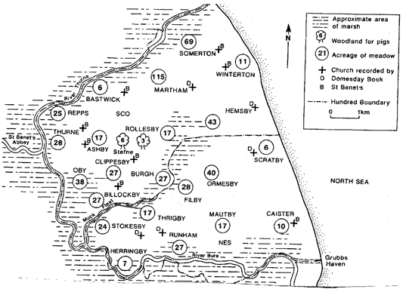
Map of Flegg Villages from Barbara Cornford's book 'Medieval Flegg'
By the end of the 10th century Local Government was also established with Martham being in the Hundred of West Flegg.
The island of Flegg with its very fertile soil had attracted a great many settlers. They all needed shelter and fuel as well as food. Therefore, it is thought that by the eleventh century, the upland of Flegg - the land above sea level - had been cleared of woodland and was under cultivation.*
*See ‘the History of the Countryside’ by Oliver Rackham.
As the land had been cleared, blocks of land suitable for ploughing were created and the various holders of the land each had strips allocated to them within the area cleared. Pathways were created to give access to them. One interesting Danish word that still survives is the Danish word 'wong'. This applies to an area that is farmed in blocks of strips. In Martham people still talk about taking 'the path through the ‘wongs' when they are going from the end of Staithe Road in the direction of Cess.
Flegg was situated with the sea on the east side and on the other sides by vast acres of wooded marshland which was liable to flooding yet ideal for grazing and numerous other purposes. Having cleared so much woodland you can imagine how delighted people must have been to realise that the peaty turf in the low-lying areas was so good to use for slow burning fires. The peat became a rich resource for the following centuries.
So, who managed everything in those far off times? By the time of the Norman Conquest in 1066 AD the Manorial system was fully established in England. The Manor of Martham was held by the Bishop of Elmham, whose steward managed everything and almost everybody. However, there were numerous independent freemen who also held land.

After the Norman Conquest in 1066 AD, everything changed as King William the Conqueror confiscated all the land and reallocated it to his chosen lords.

